Phamacokinetics(Two Day Course)

Lecture 1 : Introduction to Pk analysis
- Safety and Efficancy are the important factors
- MEC( Minimum Efficacy Conc)
- Plasma C-t data aid in understanding ADME
** IV bolus dose(intravenous bolus dose) : directly intoa vein as a single, rapid injection.
- Using AUC, can check Drug exposure.
- Clearance(CL) – ml/min, L/h
- The volume of blood cleared of drug per unit time
- Gives a sense of the drug’s elimination

- Volumn of distribution (V) - ml, L
- A mathematical term to concert drug amount to concentration
- Gives a sense of the drug’s distribution

- Bioavailability (F)
- Extent of drug absorbed into the systemic circulation upon an oral dose
- A Fraction or a percent
- Gives a sense of the drug’s absorbstion

- Linear Pharmacokinetics
- Two core assumptions ( dose and time invariant)
- Dose invariance : PK parameters do not change when the dose changes.
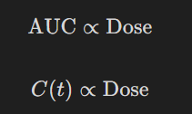
- Time invariance : PK behavior do not change with repeated dosing
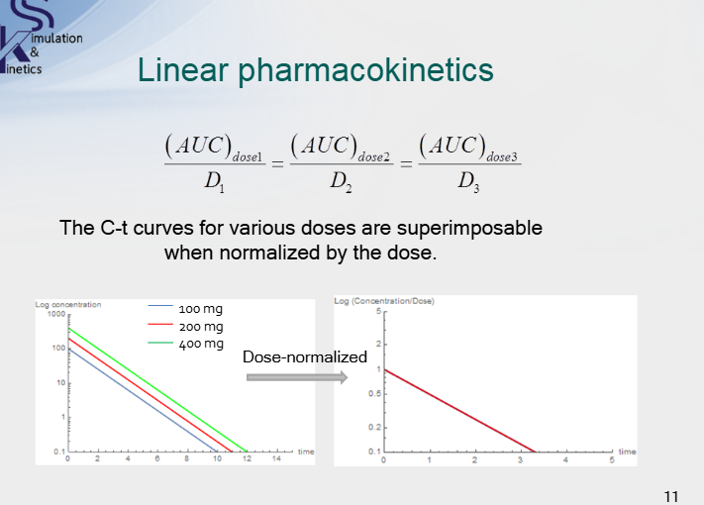
- NCA ( Non Compartment Analysis)
- Determining AUC, use trapezoid area calculation.
- 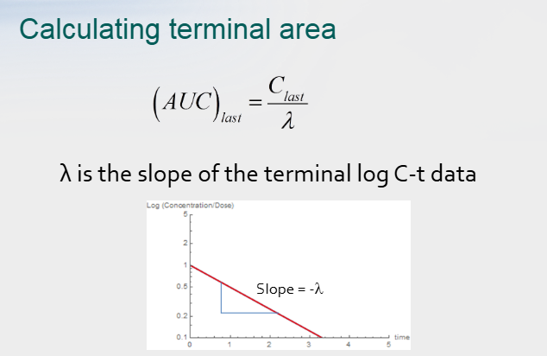

- Compartmental modeling
- Represent the body as a single compartment or a series of compartments that are reversibly linked to one another

Actual Study
- 1 Compartment Analysis
- Views the human body as one large bucket with one outflow port at the bottom.
- Compartment models can reveal insight into a drug’s underlying effects that are not always obvious.

